TEACHING COMPUTER APPLICATIONS

Overview

This interactive paper serves as a resource for experienced community college instructors, as well as for those who plan to teach computer application courses for the first time. The paper addresses teaching application packages such as word processing, spreadsheet, database, and presentation software.

Computer technology is readily available to many students, whether they have their own computers or have access through public schools and/or public libraries. This presents special challenges for teachers since their students come with a wide range of backgrounds and experience with computers. Some students will have little or no experience while others may be sophisticated users. For this reason, the computer applications teacher must be prepared to present material in a variety of ways and must be flexible in order to adjust to the students’ knowledge of computers as well as their individual learning styles.

Computer applications are being taught at all levels by teachers from varied disciplines. While much has been written about using technology in the classroom and on teaching online courses, very little actual research appears to be available concerning the pedagogy of teaching computer applications—what works and what doesn’t? How does one teach computer applications differently from other skills courses? How can students be taught to go beyond the stage of memorizing steps in learning the application so they can solve business problems on the computer? In seeking to improve instruction in this area, it is important to ask, “What does a business education teacher need to be able to do to provide the most effective environment to enable the learner to achieve success in computer application classrooms?”

Issues

In discussing ways to teach computer applications, the following issues that will be included:
- Mode of Instruction
- Relation to Knowledge Base: National and State Goals
- NBEA Standards
- SCANS
- Core Indicators
- Course and Classroom Management
- Selecting Textbook
- Maintaining Professional Level of Expertise
- Preparing Students for Certification
- Other Web links, Publishers’ Web addresses, and online papers

Mode of Instruction

Studies indicate that most people learn more readily by doing rather than by watching and listening. The computer classroom is the ideal environment for hands-on learning. The focus of the classroom is thereby switched from the instructor to the student, and the instructor’s role becomes that of a facilitator of learning with the goal of helping students apply logic and deductive reasoning while learning new software applications and solving business problems on the computer. This mode of instruction has an additional bonus in that it enables students to transfer learning so they can later apply the principles to new software applications on the job.

Suggested Activity 1

What methods (lecture, demonstration, guided practice, or self-paced)
can be used to most effectively teach computer applications?

Under what circumstances would you choose one method over another?

Visit this site for information on this topic:

http://www.tc.umn.edu/~jlambrec/technology/index.htm

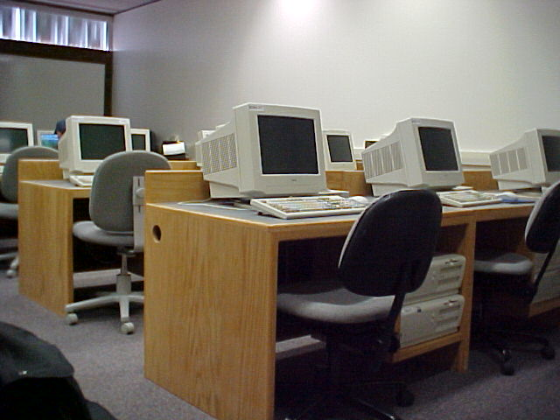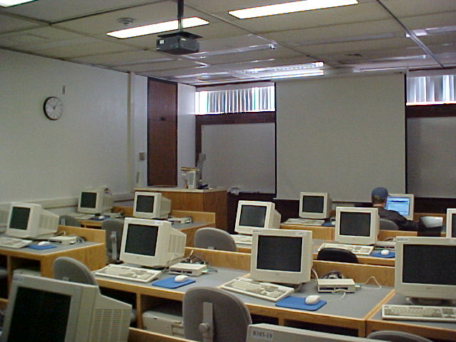

Relationship to the Knowledge Base, National and State Goals

National Business Education Association (NBEA) Standards

In 2001, the National Business Education Association published the 2nd Edition of the National Standards for Business Education. These standards examine the role of information technology in business education in the following areas: impact on society; computer architecture; operating systems, environments, and utilities; information technology and major business functions, application software; input technologies; information retrieval; network applications; information technology planning and acquisition; technical support and training; risk management; privacy and ethics; and information technology careers. The standards present a model for a comprehensive information technology curriculum. A copy of the standards may be ordered from NBEA at www.nbea.org

Suggested Activity 2

How can the NBEA Standards be used in designing curriculum?

Visit this Website for examples of standards included in the book:

National Business Education Association (NBEA), http://www.nbea.org

SCANS (Secretary’s Commission on Achieving Necessary Skills)

In 1990, Elizabeth Dole, then secretary of the Department of Labor, established the Secretary's Commission on Achieving Necessary Skills (SCANS) to determine the skills needed by young people preparing to succeed in the world of work. In 1991, the Commission presented its initial report. This report found that a high-performance workplace not only requires “workers who have a solid foundation in the basic literacy and computational skills, in the thinking skills necessary to put knowledge to work, and in the personal qualities that make workers dedicated and trustworthy.” And it also requires other competencies, such as the “the ability to manage resources, to work amicably and productively with others, to acquire and use information, to master complex systems, and to work with a variety of technologies.” (http://www.tier.net/schools/tcenters/scans.htm)

The SCANS goals of providing authentic and relevant materials for learners and developing decision-making, problem-solving, and critical-thinking skills are especially applicable to the information technology curriculum.
In the area of technology, the SCANS report suggests that all students preparing for the workforce should have the following skills:
- C18 Selects Technology
Judges, which set of procedures, tools, or machines, including computers and their programs, will produce the desired results.
- C19 Applies Technology to Task
Understands the overall intent and the proper procedures for setting up and operating machines, including computers and their programming systems.
- C20 Maintains and Troubleshoots Technology
Prevents, identifies, or solves problems in machines, computers, and other technologies (SCANS 2000 Workforce Skills Website, 1991).
Note that the emphasis is on preparing students to make decisions and to solve problems with technology. As teachers, it becomes essential to not only teach the software but to help students develop the ability to determine which software is most effective in any given circumstance. Students must be taught to solve problems on their own.

Suggested Activity 3

What strategies can be used to help students learn
to use the SCANS competencies?

Visit these Websites:

http://www.scans.jhu.edu/NS/HTML/SkillsDet.htm
http://www.academicinnovations.com/report.html

Educational Performance Accountability

In addition to established business and industry work standards, many states throughout the country have established outcome measures for students being trained and educated in vocational areas. VTEA Core Indicators, as established in the state of California, measure student and program success. Federal funding for vocational programs is determined by the degree of progress made on the core standards. When developing instructional experiences, it is important to incorporate strategies that will enhance opportunities for student success as measured by these core indicators.

Suggested Activity 4

Define the Core Indicators as established in the State of California.

Check these resources:

Vocational and Technical Education Act (VTEA)
Core Indicator Performance
http://www.rsccd.org/research/pdf/VTEA%20Core%20Indicators%202001-02.pdf

Core Indicator Reports
http://webdata2.cccco.edu/VTEA_RPTS.htm

What could you do or provide in your classes to help students succeed?

Course and Classroom Management

The first step in designing an effective computer course is to carefully examine the course objectives—what should students achieve in this course? To develop clear and meaningful objectives, the instructor must understand how this course fits into the entire curriculum. If the objective is to prepare students for employment, take a careful look at employer needs in designing the course.

In determining the objectives, it is important to have a very good idea of the background and learning styles of potential students that will be involved. Visit the following sites for information on learning styles:

Suggested Activity 4

What do you expect your students to achieve in your computer applications
course, considering learning styles and employment requirements?

http://www.d.umn.edu/student/loon/acad/strat/lrnsty.html
http://snow.utoronto.ca/Learn2/mod3/targets3.html
http://tip.psychology.org/computer.html.

The next obvious step is to examine the resources. What type of classroom facility will be used? If it is a computer lab, examine the hardware and software available. If the students will be completing assignments on computers outside of the classroom, what resources are available to them? What technical support will be available? What kind of multi-media resources are in the classroom? How can these resources be used most effectively?

As a part of this second step, select a textbook that will help meet the objectives that have been established. A good textbook with appropriate supplementary material will make the work much easier for an instructor. Listed below are several Websites that contain criteria for selecting high-quality textbooks. This information will assist in determining the most appropriate textbook for a particular class.

Suggested Activity 5

What content would a good text include, and how should it be organized?

Textbook Evaluation
www.teflweb-j.org/garinger.html

General Textbook Readability Checklist
http://www.hope.edu/academic/education/wessman/Secondary_Block_Revised/assignments/textbookchecklist.htm

Mathematics Textbook Evaluation
http://mathstar.nmsu.edu/texts/texteval.pdf

The third step would be to prepare a meaningful syllabus. A well-designed syllabus will serve as the students’ roadmap through your course. Many institutions consider the syllabus to be a contract with the students. It is vital that students understand the importance of the syllabus.

Suggested Activity 6

Examine model syllabi for ideas that could be incorporated
in courses being taught.

Visit this website for information on syllabus development:

http://www.hcc.hawaii.edu/intranet/committees/FacDevCom/guidebk/teachtip/develsyl.htm

An important part of the course design, of course, is assessment. How will students’ progress be evaluated? What portion of the students’ homework will be graded? What measures will be used to ensure that course objectives are being met? If the assessment material that accompanies the textbook is being used, make sure that these materials meet the objectives set for the students.

In preparing for the first day, develop a plan for introducing the course to the students—the first day sets the tone for the course. It is important to make sure that the course objectives are clear and that the students understand how to meet those objectives. Establish a plan for getting to know the students and have a plan for tracking each student’s progress through the course.

As the course progresses, monitor student learning—make sure that objectives are being met. Develop a plan for intervention if progress is not being made. Keep a journal of what works well and what should be done differently when the class is taught again. Have the students evaluate the course and instructor; use this input to make instruction more effective in the future.

Selecting Textbooks

Publishing companies often provide excellent instructional resources for teachers adopting their textbooks. These may come in the form of printed or online teachers’ manuals that include solutions for exercises, course syllabi, lesson plans, and exams. The instructional support is an important factor in selecting textbooks for many teachers; however, the bottom line is “does the textbook meet the established objectives of the class?” Does the author present the material in a meaningful and easy-to-follow way? Are the student activities relevant? Are the instructions clear? Is the reading level appropriate for the students? Will the student develop problem-solving skills that will carry over to other applications, or will he or she be hampered by instructions that encourage memorization of steps?

Suggested Activity 7

What would be an appropriate textbook for the course you will be teaching?

Visit the following Websites:

www.teflweb-j.org/garinger.html
http://mathstar.nmsu.edu/texts/chart.html

Maintaining Professional Level of Expertise

One concern for teachers of computer application courses is finding time to learn the new software. If the teacher is responsible for teaching several software courses with frequent upgrades, he or she cannot hope to know all there is to know about each application. It is important to recognize that the teacher is the facilitator of learning. While the instructor who has all the answers may be very impressive, it is normally more beneficial for the instructor to help the students find the answers for themselves.

Keeping current with new software may require self-study, additional coursework, or sometimes even learning right along with the students. In addition, professional organizations offer many opportunities for the computer application instructor who wants to maintain a professional level of expertise. State, regional, and national business education associations offer workshops on new computer applications along with other opportunities for networking and sharing ideas.

Suggested Activity 8

Be professional!

Join your state, regional, and national business education associations. Attend conferences and seek opportunities for professional growth and leadership. If you are a business education major, interested in business, or working in business, it is strongly recommended that you become a member of one or more of the professional associations for business educators.

Check out the websites to see how you can become a part of these organizations:

- National Associations:
National Business Education Association (NBEA), http://www.nbea.org/
Delta Pi Epsilon (DPE), http://www.dpe.org/

- Regional Association: Western Business & Information Technology Educators (WBITE) or other regional association in your area, http://www.wbite.org/

- International Business Education Association:
- International Society for Business Education (ISBE),
http://www.siec-isbe.org

- National Honorary Society in Business Education:
Delta Pi Epsilon (DPE), http://www.dpe.org

- State Association:
California Business Education Association (CBEA), http://www.cbeaonline.org/

Preparing Students for Certification

A trend in business today is toward certification. In a highly competitive job market, having a recognized certificate may make a difference to students as they seek employment. Microsoft provides Microsoft Office User Specialist (MOUS) certification exams for their office suite. Business teachers, along with advisory committees, must determine what part of the curriculum should be devoted to preparing students for this type of certification. At the very least, computer application teachers should be familiar with available certification.

Suggested Activity 9

Find out about MOUS certification—
where, in your area, are certification exams administered?

Prepare for and take one of the exams—this not only will add to your own credibility but also will give you insight into the level of difficulty and value of the certification. Learn more about MOUS testing and how to establish a testing center by visiting the Websites listed below.

http://www.microsoft.com/traincert/mcp/mous/default.asp
http://ivc-dl2.ivc.cc.ca.us/sspc/

Other Web Links

Judith J. Lambrecht, “Developing Employment-Related Office Technology Skills”
Berkeley: National Center for Research in Vocational Education, University of California.
http://www.tc.umn.edu/~jlambrec/technology/index.htm
Visit this excellent Website that reports on a project that was designed “to develop guidelines for teaching employment-related office technology skills, particularly those offered in office technology, based on the practices in schools already judged to be exemplary in their program design and teaching practices.”

“The BTE Toolbox "Special Methods of Teaching Business Education" www.coedu.usf.edu/btetoolbox
Check out the section entitled “From Teacher…to Facilitator” for an opinion paper comparing traditional and self-directed learning styles. This site also includes information on the SCANS Report.

Tonya Skinner
www.angelfire.com/ks/tonyaskinner/index.html
Ms. Skinner provides sample lesson plans for computer courses, along with other useful ideas and tips for the computer classroom.

Computer Science and Business Education Website for Crews Middle School (Georgia).
http://www.crews.org/curriculum/ex/compsci/index.htm
The author has compiled links to interesting articles, which include topics on computer viruses, computer ethics, and software ethics.

Microsoft Education
http://www.microsoft.com/education/?ID=InstructionalResources
Microsoft Education provides lesson plans, tutorials, and other instructional resources for using the MS Office Suite in the classroom.

Jan’s Illustrated Computer Literacy 101
http://www.jegsworks.com/Lessons/index.html
Jan Smith has prepared extensive tutorials including quizzes and exercises on many computer application topics.

Developing Computer Literacy
http://ericit.org/digests/EDO-IR-1996-04.shtml
The author discusses computer literacy and how it can be taught. The article also contains a suggested curriculum for developing problem solving skills using the computer.

Curricular Issues in Business Technology
http://www.crews.org/curriculum/ex/compsci
This site pulls together a number of links for research articles on curricular issues in business education including technology education

Instructional Design
http://www.lc.capellauniversity.edu/~ee2885/IDPaperAbstractSummary1.htm
At this site, you can access a series of interactive white papers on instruction delivery principles.

Developing a Course Syllabus
http://www.hcc.hawaii.edu/intranet/committees/FacDevCom/guidebk/teachtip/develsyl.htm and http://www.hcc.hawaii.edu/intranet/committees/FacDevCom/guidebk/teachtip/teachtip.htm
The first site lists 17 possible functions of a course syllabus. The second site provides an index of teaching tips and other useful information in course development, including a sample syllabus.

Learning Styles
http://www.d.umn.edu/student/loon/acad/strat/lrnsty.html
http://snow.utoronto.ca/Learn2/mod3/targets3.html
http://tip.psychology.org/computer.html.
These sites provide background information on learning styles, which might be useful as you develop course materials designed to meet the needs of your students.

Computer Teaching Tips
http://www.emunix.emich.edu/~krause/Tips/
This article contains information on word processing ideas—how to most effectively use word processing application packages.

Computer Resources
http://earthvision.asu.edu/~rader/bused/
This Website contains information on business education resources with lots of links to sites that would be helpful for those teaching business education classes.

Contextual Learning Resources
http://www.cord.org/
This article is very appropriate for computer application instructors as it discusses the concept of contextual learning. From the article, it is possible to learn about the ramifications for business education.

Computer Skills for Information Problem-Solving
http://ericit.org/digests/EDO-IR-1996-04
This article discusses problem-solving skills in learning and teaching technology.

MOUS Certification
http://www.microsoft.com/traincert/mcp/mous/default.asp
Find out how you can obtain MOUS certification for yourself and your students.

Teaching Sites on the Web
http://www.unc.edu/~healdric/soci380/weblinks.html
This site contains a wealth of links to teaching resources on the Web.

Computer Ethics
http://cyberethics.cbi.msstate.edu/biblio/part2.htm
This site provides an extensive bibliography of current textbooks that can be used in computers, ethics, and society courses.

Using Notebook Computers in the Classroom
www.crk.umn.edu/technology/thinkpadu/thinkpadmobile.htm
The University of Minnesota presents findings about barriers in providing computer instruction and using mobile computers as a solution.

Improving College Teaching
http://www.olemiss.edu/depts/vc_academic_affairs/improve.html
Dr. Peter Seldin suggests ways to improve the level of instruction at the college level.

Learning Styles
http://www2.ncsu.edu/unity/lockers/users/f/felder/public/Learning_Styles.html
Dr. Richard Felder has posted a number of interesting scenarios on student learning styles. He is an engineering professor, but his observations are relevant to the computer class environment as well.

Publishing Companies (Catalogs and Online Support)

Course Technology
www.course.com
Catalog of available textbooks along with student and instructional support.

DDC Publishing
www.ddcpub.com
Check out teacher resources. Beyond the Book provides additional activities for your students.

Glencoe McGraw Hill Publishing Company
www.glencoe.com
Describes available textbooks and other resources along with instructional support articles and materials.

Paradigm Publishing Company
www.emcp.com
Lists and describes available computer textbooks. There is also a demo site for the “WEB Class Connection” feature that is available when textbooks are adopted.

South-Western, Thomson Learning
www.swep.com
This site provides information about current textbook offerings. South-Western also publishes a monthly online newsletter called The Balance Sheet. Check for relevant articles in current and archived issues of this newsletter.

Suggested Computer Education Literature:

National Business Education 2002 Yearbook, Technology, Methodology, and Business Education, National Business Education Association, c 2002.
This issue is devoted to technology, learners, and learning environments and has a wealth of information written by leading business educators from all over the USA. We recommend that a copy be purchased from NBEA (www.nbea.org as an addition to your professional library.

Lundgren, Lundgren, Mundrake. Teaching Computer Applications, Delta Pi Epsilon, 1995.
Although somewhat out of date, this publication has relevant suggestions for selecting textbooks and software, planning lessons, and assessing students in computer application classes.

McInerney, V., McInerney, D. M., & Sinclair, K. E. “Student teachers, computer anxiety, and computer experience.” Journal of Educational Computing Research, Vol. 11/1, p. 27-50, 1998.

National Standards for Business Education, NBEA, 2001, pp, 81-90.

Smith-Weber, Sheila M. Computer self-efficacy: An examination of the sources and the impact of computer technology education. NABTE Review, No. 27: 53-58, 2000.

“Student perceptions regarding use of technology in teaching computer courses,” Southern Illinois University, Carbondale, Master’s thesis, 1999.

Fulk, H. Roger. “Assessment in technology-based business education courses,” OBTE, Vol. 59, p. 32-35, 2000.

Zeliff, N., & Schultz, K. Authentic assessment in action: Preparing for the business workplace. Little Rock AR: Delta Pi Epsilon, 1998.

